Building a Leaderboard & Rock, Paper, Scissor Apps

# Extra Challenges

You may use AI to help with these extra coding challenges. However, try not to ask the AI for the final answer. Ask it to guide you instead. You can say:

“Help me solve Python coding challenges, but please do not give me the code. Instead, guide me step by step on what to do.”

# Challenge 1 (Medium)

You will write code in the **get_current_position_on_leaderboard** function

# Open rock_paper_scissor.py.

# Inside the file, complete the code in the get_current_position_on_leaderboard.

# This function should take in a client_id.

# Use the endpoint "/get_leadership.php".

# The request must be sent using the GET method.

Expected Results:

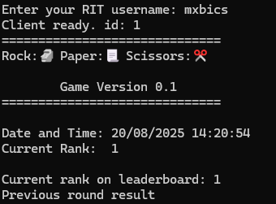

# Challenge 2 (Medium Hard):

Use Python’s TQDM package to show a loading bar in the **get_computer_choice()** while the computer is “thinking.” Put the code in between:

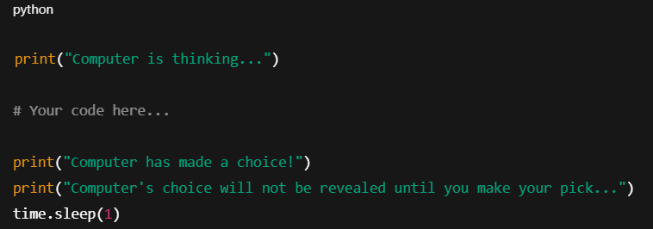

Expected Results:

